Gabriele D'Annunzio - Poet of the skies

We write the year 1909. It’s September in Brescia, the old capitol city of Lombardy. Thousands of sightseers have come together under the mediterranian sun, to see the planes and the pilots as well as the italian nobles and celebrities. The creme de la creme of the american and french aviation scene can be seen through the binoculars - Louis Blériot, Glen Curtiss, Henri Rougier - who frolic around in a picturesque crowd of italian celebrities and nobles - prinicpessas, contessas and members of the italian Bonaparte branch. Even Kafka can be found, at the time still unknown, writing a report for the Bohemian "Morgen-Ausgabe" about the Brescian Aviationshow.
Amongst all these people is a man of small stature, with a lively demeanor and yellow shoes. Many will recognize him as Gabrielle D'Annunzio, at the time already famous and highly discussed in the italian society. His excited dancing around may seem typical for him, but
many of the sightseers will not experience the real reason for his excitement. D'Annunzio has not come as a mere spectator. Three days later, on 12th September, he and Glen Curtiss get ready to give D'Annunzio a futurist kind of baptism. A baptism of the air, of the skies. D'Annunzio is to fly for the first time on a plane.
Strapped into a second seat of Curtis's plane, he eagerly awaits the lift off. Unfortunately the plane barely climbs up, only for a short time the people can see D'Annunzio hover closely over the tops of palm trees, before the plane descends again, but an alternative is quickly arranged. On a military plane, provided by an italian lieutenant from the Marina "Marie Calderada". Now D'Annunzio is finally flying.
For a long time he is in the air, traveling the italian landscape in this silent dawn. When he and his pilot finally land, he immediatly announces to the awaiting crowd that from now on he wishes to become a pilot: "Una sensazione divina!", he proclaims. "An intensive feeling of bliss! When you lift of, it feels like you are free from the matter of earth. You feel light, ethereal, transfigured!"
It seems fitting that D'Annunzio experiences his aeronautic baptism on board of an italian military plane, since the path of his aviatic adventures would lead him closely connected to the italian military - and aeronautic war.

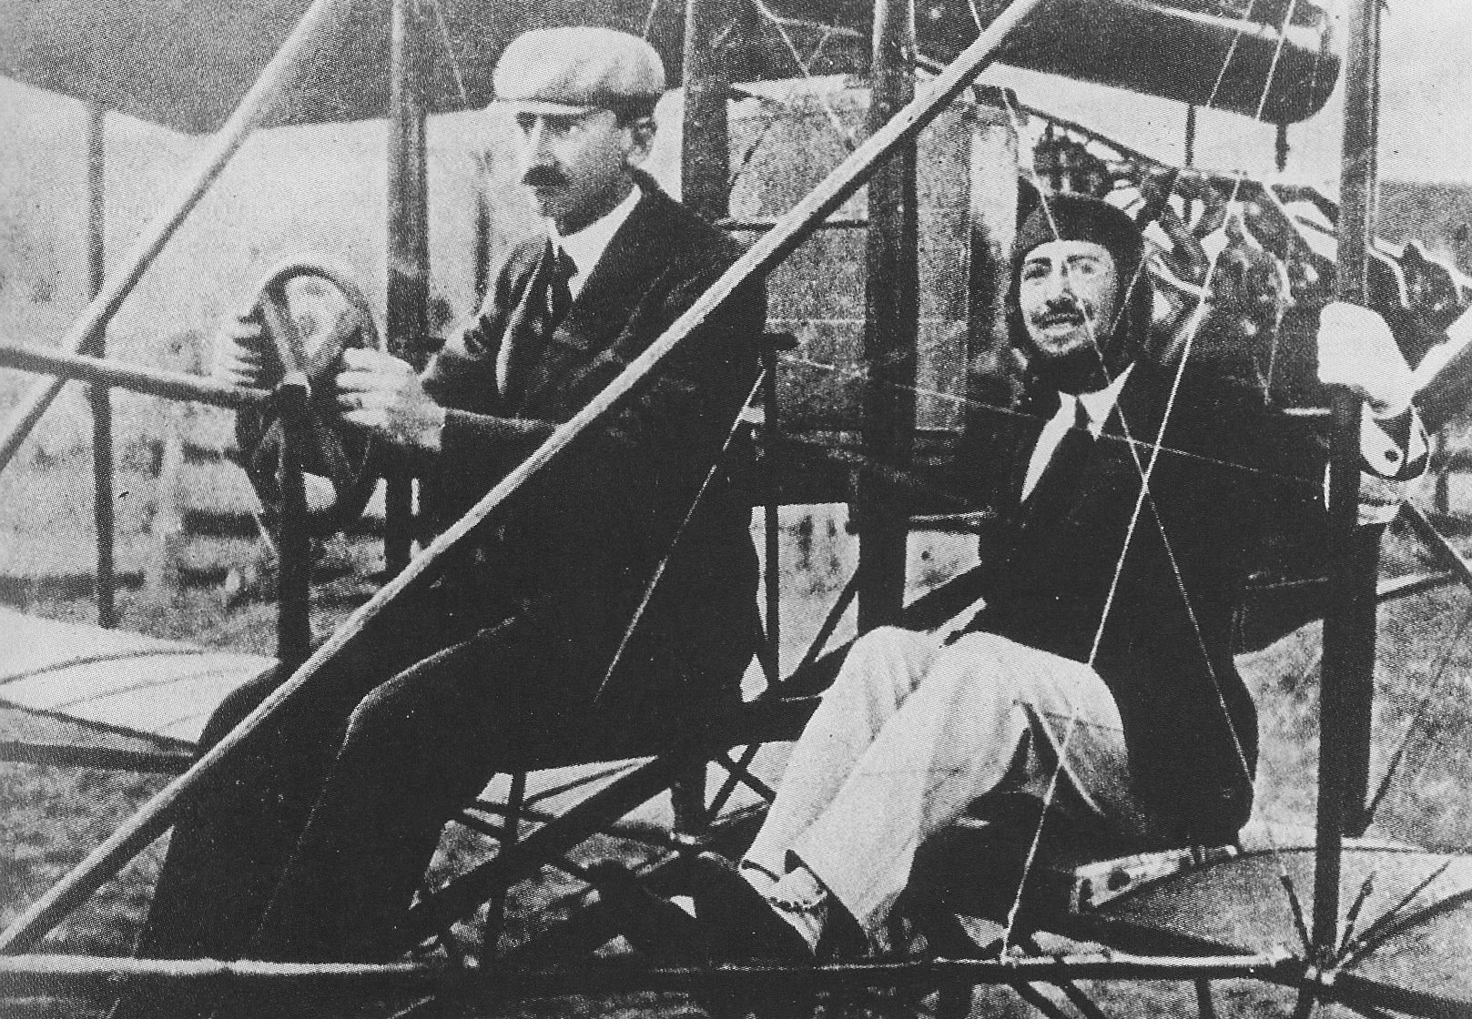
Glen Curtiss and Gabriele D'Annunzio

In the month following the Brescian Aviationshow d’Annunzio finishes his next novel - Forse che ni, forse che no -, which is consequently about pilots who are chasing after long-distance records with their planes and ultimately risk or outright sacrifice their lifes for the new records. It goes to show how intensely D’Annunzio connects his romantic heroism with the new era of aviation.
Additionally his fervor for this endeavor inspires a revolutionary filming technique, nowadays known as a “tracking shot”. In the silent film “Cabiria”, D’Annunzio directs a new kind of filming, that makes use of the huge sets that have been created for this film: The camera is mounted on a dolly, that allows it to follow the action and move inside a set or environment. The new key element was the possibility to have long scenes without any cut, that have “zoom”-movements towards and away from scenes as well as up- and downmovements of the camera, independently from the actors movements.
Even the great D. W. Griffith scratched his head for a while trying to get behind the secret of the “Cabiria Movement”, sometimes even using balloons to hold up a camera.
Although D’Annunzio proclaimed very little interest in the new medium film - as he is famously quoted, that he never watched a single film in his life -, his experience with cameras would translate into his aeronautic endeavours.

Years go by and the bells of war begin toll across Europe. D’Annunzio is now 52 years old and with his fervent help via public speeches, Italy gets ready to join the war. Consequently D’Annunzio joins the army and decides to become part of the aviatic branch. In the following years d’Annunzio leads an important role in the aeronautic warfare.
Despite his age he participates in multiple active duties in the sky. In February 1916 he crashes, looses his right eye and almost becomes blind in his left eye, until he finally recovers after months of derangements. But this is not stopping him, and very soon he is in the air again, leading the bombardment of Parenzo in July 1916.
Together with bombing runs, D’Annunzio also paved the way in the Italian Air Force for a new kind of reconnaissance flight. A duty that used to depend on troops on the ground or mere eyesight reports can now be done with the plane and a camera attached to the bottom. His enthusiasm as well as technical understanding of the matter further consolidate italian air-superiority. Working closely with Gianno Capproni he developes a plane with - at the time - extraordinary long-distance flight capabilities.
On his own accord he is transfered to the bombing squadron of Major Ernesto La Polla, which is directly under the rule of the Comando Supremo. In August he participates in three bombardments of the fortress Pola, in September he bombards the city Cattaro.
In May 1918 he founds his own squadron “San Marco”, consisting of three units: fighterplanes, bombers and as a worlds first - torpedo planes. With this new squadron he has more successful bombing runs on Pola.
But despite all these technical and seemingly material characteristics, D’Annunzio is still a poet, still a man of the arts and of ultimate heroic ideals. To quote Jonathan Bowden:

It’s noticeable that the war in the air attracted a debonair, an individualistic, and an aristocratic penchant. Figures as diverse as Goering in the German air force and Moseley in the British air force and D’Annunzio in the Italian air force all fought a war that in its way had little to do with the extraordinarily mechanized armies that were fighting on the ground.
You had this strange differentiation between massive armies and fortifications of steel with tunnels turning the surface of the Earth like the surface of the moon down on the ground until tanks were developed that could cut through the sterile nature of the attrition of the front – a very static form of warfare from 1915 until the war’s end in 1918 – and yet above it you had this freedom of combat, this freedom in the air with biplanes which were stretched together from canvas and wood and wire and were extraordinarily flimsy by modern standards, [...].
There was a cult of chivalry on all sides in the air which really didn’t superintend on the massive forces that were arrayed against each other on the ground, and this enabled a spiritual dimension to the war in the air that was commented upon by many of the men who fought at that level. This in turn reflected the sort of joie de vivre and the belief in danger and force that aligned D’Annunzio with the futurist movement of Marinetti and with many anti-bourgeois currents in cultural and aesthetic life at the time.
In his report “On the usage of bombing squadrons in the following operations” commissioned by Luigi Cadorna, Chief of Staff of the Italian Army, it becomes clear that for D’Annunzio the aeronautical warfare is tightly connected to heroic ideals and to the fate and ultimate destiny of his nation and its people. He writes:

In the hell of Verdun, at a time when the iron barrior of the Reich was the strongest - when even the most battle hardened warrior could no longer withstand the thundering and roaring insanities - a squadron of republican planes, the biggest that has been assembled in France up to this date, attacked in a single line the enemy infantry which quivered as if they were struck by thunder. The heavenly army accompanied the earthly army to the sublime sacrifice, as if it were in a communion of the Fatherlands extended free space.
The battle cry broke into all hearths, swelled up by sudden courage and excelled the roaring thunder of the romanesque wings.

Further into the report, he demands that the training of pilots has to be improved. He wants to build up an elite unit, but not only elite in their technical abilites but also in their minds:

The selection has to be strict, the requirements even stricter. The warrior instinct of the winged pair has to be as deep-rooted and perserving as their aeronautical instinct. It has already been said, that the Holocaust is the highest order of glory for a winged pair: the sacrifice (sacrifizio), in which the whole sacrifice (vittirna) is burned.
“Those who surrender themselfes and their wings to the enemy, have sinned their fatherland, the spirit and the sky. No matter if unlucky or shameless, they loose every right for glory.”
This has to be the honorcodex for all pilots and all companions. This has to be written onto the canvas, the wood, the sheet, the cement, the stone, every single place that houses planes and pilots.
Our hearths tremble of proudness with each emergence of extraordinary heroes.
The lieutenant Ugo Niutta from Naples encountered two enemy planes during a reconnaissance mission and approached them in keen courage. He managed to down one plane, but with the second plane still around he suffered the death of this companion and his plane damaged, unfit to continue fighting. Yet he did not think about landing safely on the ground and surrending to the enemy. He tried reaching our battle line, flying low avoiding tight enemy fire, but he was deadly hit and his in final moments he maneuvered his wings to its death, to shatter on the rock of Rio Torre. Thus the plane, the hero and the corpse of his companion shred and burned, but from the pyre of the wreck and the bones the unstained victory takes off: mors vitoria vitae.

Considering all this, it is not surprising that he also participates in many bombing runs that do not drop bombs - but propaganda leaflets. Leaflets riddled with nationalistic poetry, bombarding the subjected population with rethoric so raw and unbridled that they might as well have been real bombs. D’Annunzio couples the rethoric with the inevitable display of italian air superiority and the poetic mercy of a squadron, that might have been the bringer of death but chose not to.
The first of such expeditions is lead by D’Annunzio on 7th August 1915 and drops leaflet bombs on the austrian city Triest. In September he hit the city Trient, in December Zara.
On the 9th August 1918 d’Annunzios propaganda air raids reach their peak. With his squadron “La Serenissma” - consisting of one double-decker and seven single-deckers - they begin their dangerous journey at 5:50 AM in the morning. Thei target is more than 300km into enemy territory: Vienna - the capital city of Austria.
On their journey to Vienna the squadron gets sighted by vision or sound multiple times, but never clearly enough to really instigate any kind of counter measures by the enemy. At 8:10 AM the sqadron has reached their maximum height of 3.650m and is far above the clouds which shields them from any investigating pair of eyes.
It is around 9:00 AM when they reach Vienna and begin the nosedive onto the city. What follows is history: 400.000 leaflets were droppped, with italian text written by D’Annunzio and german translations written by Ugo Ojetti. They manage to drop leaflets over various parts of the city and take multiple pictures and finally escape undisturbed.
In the following days the huge international media response was mostly positive, with the Times and the Daily Telegraph congratulating this endeavour. In the austrian media this action put the country into a state of general alarm, since this public display of aerial vulnerability begged the question how these italian planes could operate completely uninterrupted. Nontheless there were austrian voices who also congratulated the skill of the italian pilots and namely the bravery of D’Annunzio.

Leaflet by D’Annunzio

“We came in the wind of victory which descends from the rivers of freedom, solely for the joy of courage, solely to prove what we dare and are capable of no matter what hour we choose.
The thunder of the youthful italian wings is not the same as the deathbell from the morning sky. Nontheless, a single irrevocably saying of cheerful boldness spans between the St. Stephan and the Graben, oh you dear Viennese.
LONG LIFE ITALY!”

Leaflet by Ugo Ojetti

“VIENNESE!
Learn to know the Italians.
We are flying over Vienna; we could drop tons of bombs. All we are dropping on you is a greeting of three colors: the three colors of liberty.
We Italians do not make war on children, on old people, on women.
We are making war on your government, the enemy of national liberties, on your blind, stubborn, cruel government that can give you neither peace nor bread, and feeds you hatred and illusions.
VIENNESE!
You are famous for being intelligent. But why have you put on the Prussian uniform? By now, you see, the whole world has turned against you.
You want to continue the war? Continue it; it's your suicide. What do you hope for? The decisive victory promised to you by the Prussian generals? Their decisive victory is like the bread of Ukraine: You die waiting for it.
PEOPLE OF VIENNA, think of your own fates. Wake up!
LONG LIVE LIBERTY!
LONG LIVE ITALY!
LONG LIVE THE ENTENTE!”

Further Readings
Franz Kafka, “Die Aeroplane in Brescia”, Bohemia, 29.Sept. 1909
Gabriele D’Annunzio, “Forse che ni, forse che no”, 1910
Jonathan Bowden, “Gabrielle D’Annunzio”, 21. Jan. 2012

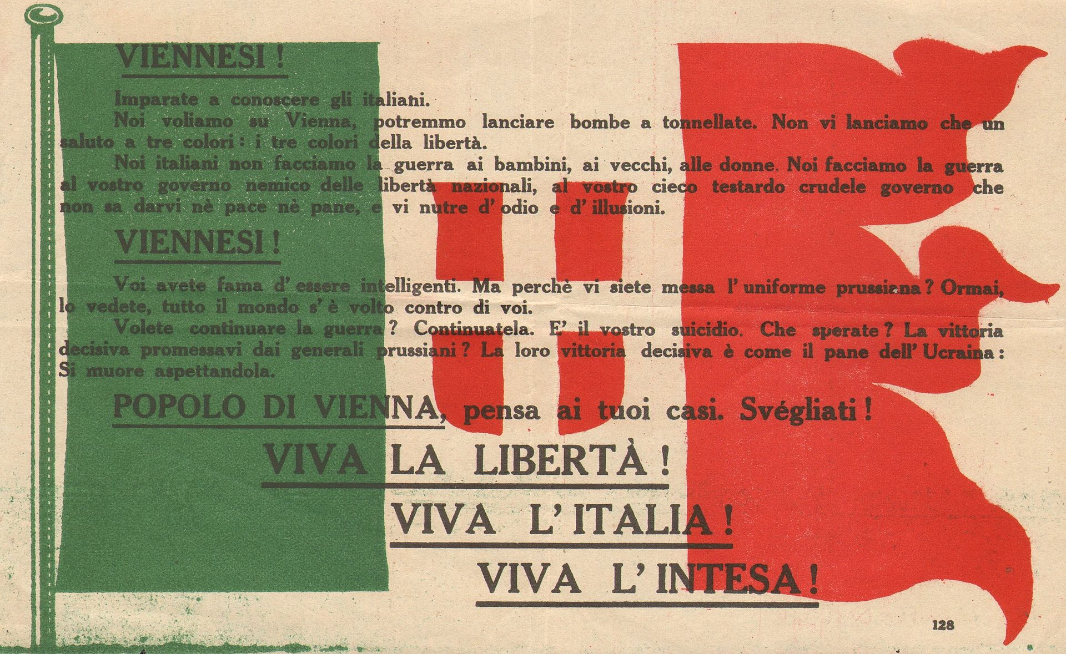
Leaflet dropped over Vienna
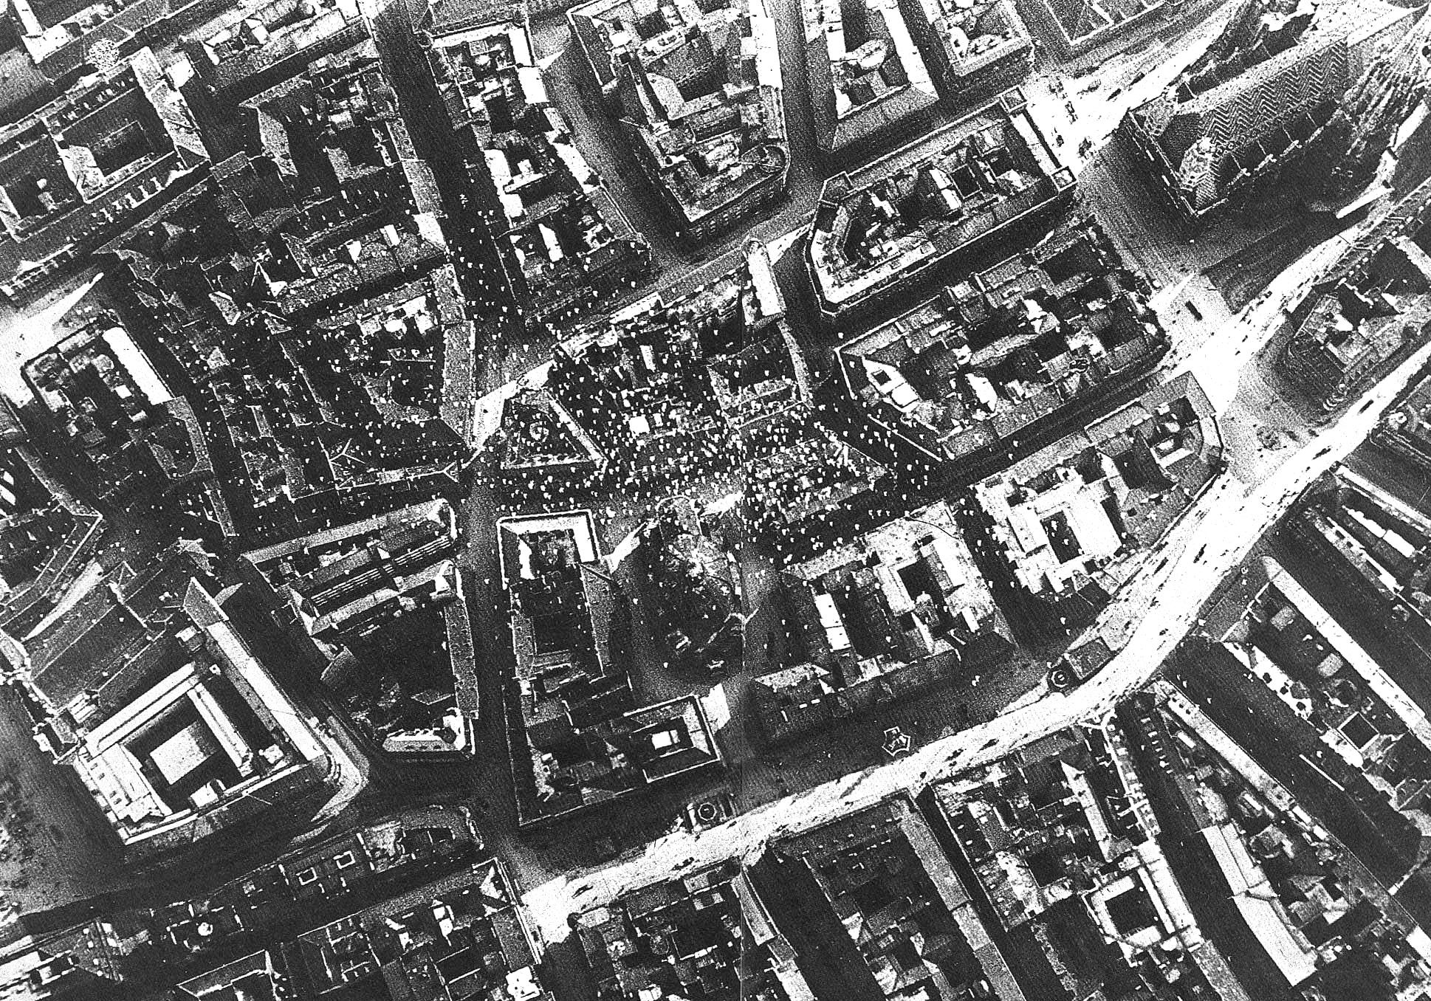
Picture taken over Vienna after dropping leaflets (St. Stephen’s Cathedral in the upper right corner)

